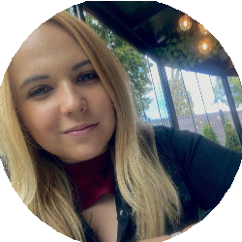

Karyna Mishchenko
Date of birth: 15/09/1997 Nationality: Polish/Ukrainian
Gender: Male

CONTACT
Boya Żeleńskiego 10/18, 4
ﬂoor
91-704 Łódź, Poland (Home)
karinamischenko72@gmail.co m
(+48) 537896165

WORK EXPERIENCE:
29/03/2021 – CURRENT – Łódź, Poland

logistics coordinator

Tom-Gast sp z o.o/ TGLM sp z o.o
Coordinating and supervising the work of the logistics department
Managing subordinate staﬀ, including motivating employees and accounting for the time and results of their work
Controlling the entry of goods into the company, storage, production supply and goods exit (internal logistics)
Controlling the costs of internal and external logistics
Cooperation with other departments in the process of implementing new logistics projects
Negotiating and concluding contracts
Conducting internal training in the procedures and logistic systems used
Providing the subordinate team with a safe working environment, ensuring compliance with health and safety regulations, ﬁre protection. And environmental protection

01/10/2015 – 01/10/2020 – Łódź, Poland
Qality controller leader Exact Systems sp z o.o Checking the quality of production Repair of parts of production Production standard analysis Record keeping
Analysis of work results.

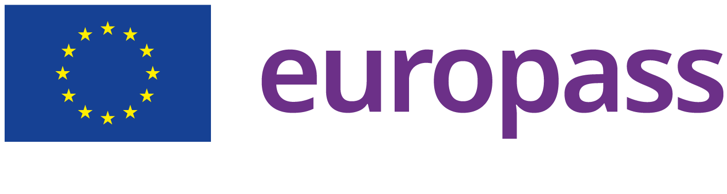

EDUCATION AND TRAINING:
01/10/2015 – 01/10/2018 – Łódź, Poland

bachelor of international relations/ International communication

University of Łódź/ Uniwersytet Łódzki
Address Składowa 43, 43, Łódź, Poland | Website https:// www.wsmip.uni.lodz.pl/

01/10/2018 – 01/10/2020 – Łódź, Poland

magister of international relations/ Arabic studies

University of Łódź/ Uniwersytet Łódzki
Address Składowa 43, Łódź, Poland | Website https:// www.wsmip.uni.lodz.pl/

01/09/2013 – 01/09/2015 – Dnipro, Ukraine

High School № 7

Pupil
Address Tverska 18, Dnipro, Ukraine | Website https://dp.isuo.org/ ru/schools/view/id/2738

01/09/2004 – 01/09/2013 – Dnipro, Ukraine

pupil

Secondary School № 45
Address Soﬁa Kovalevska 88-a, Dnipro, Ukraine | Website https://kzoszch45.dnepredu.com/uk/site/ kontakti.html

LANGUAGE SKILLS:
MOTHER TONGUE(S): Ukrainian, Russian

OTHER LANGUAGE(S):
English

Listening
B1

Reading
B1

Spoken production B1
Spoken interaction B1

Writing
B1

Polish

Listening
C1

Reading
C1

Spoken production C1

Spoken interaction C1

Writing
C1

German

Listening
A1

Reading
A1

Spoken production A1

Spoken interaction A1

Writing
A1

DRIVING SKILLS:

Driving License : B

DIGITAL SKILLS:
Microsoft Word / Microsoft Oﬃce / Microsoft Excel / Microsoft Powerpoint / Zoom / Outlook / Skype
/ Facebook / Social Media / Power Point / Internet user / Organizational and planning skills

